**PROJECT MANAGEMENT SYSTEM**

**Team Member:**

* Jie Zhu
* Jing Wang

**Project Purpose and Content**

* **Purpose**

This project will deliver a Project Management System, which help PMs (Project manager) and members efficiently manage projects and related tasks.

* **Content**

The project will cover the following main aspects:

1. User management;
2. Project/task management, including project/task maintenance, PM/project member assignment, and task reminder;
3. Reports, such as project completed rate report, all/selected projects & tasks report.

**List of Technologies, Libraries, Components used**

* **Technologies**  
  Java, Database(MySql)
* **Libraries**  
  MySQL JDBC driver, JDring
* **Components**JTree, JList, JButton, JTestField, JLable, JFileChooser,JCheckBox, JMenuBar, Jpanel, JTable

**Database Structure**

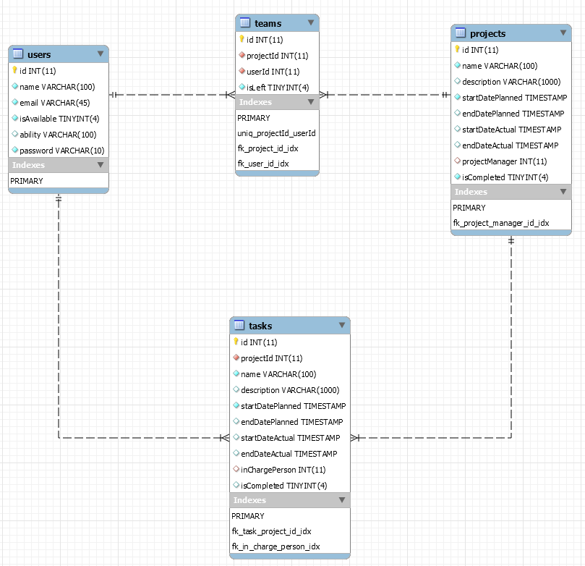

**Screenshots of Main Windows**

* User login

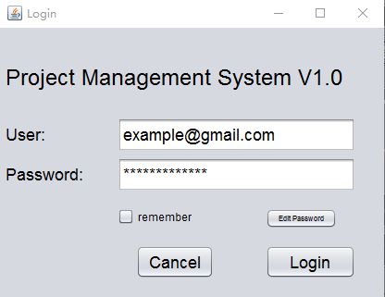

* Project List

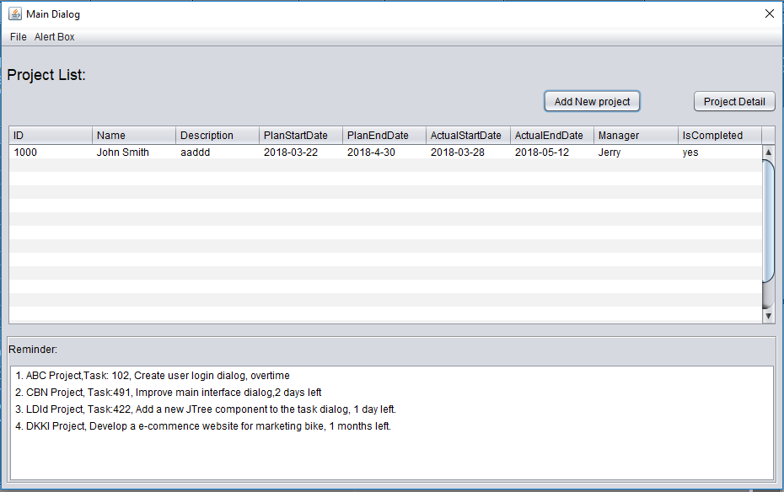

* Project maintenance

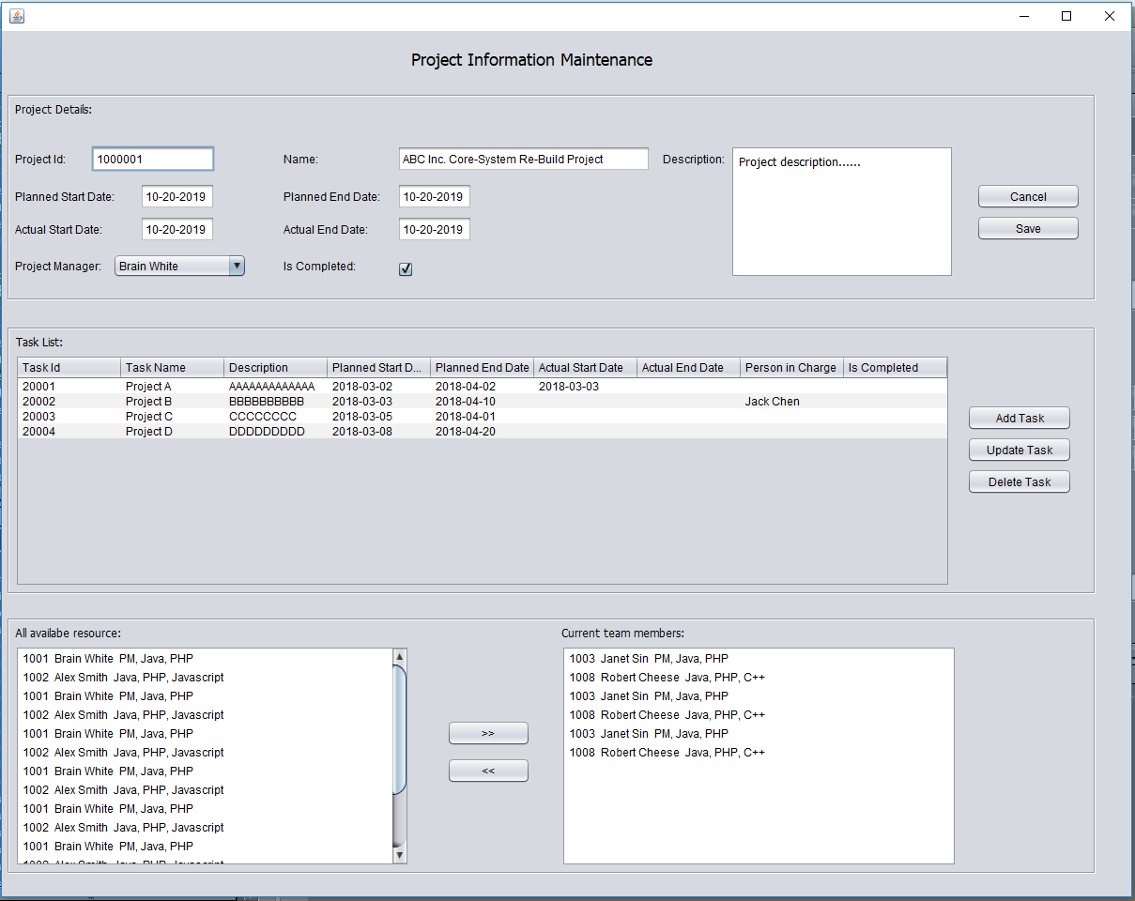

* Task Maintenance

